Team 43

40432720

40428196

40435293

40444263

40288696

WiP – Projex Redesign Team 43

Robinson, Jon

Contents

1: Executive summary 2

2: Delivered product 3

Must Have Deliverables 3

Should Have Deliverables 3

Could Have Deliverables 3

Won’t Have Deliverables 3

3: Closing audit 4

4: Lessons learned 5

5: Team Contribution 6

Appendix 7

# 1: Executive summary

The main goal of project is to - from a student’s point of view -redesign the Projex webapp used by student and faculty to facilitate the group and project finding process for Edinburgh Napier University students. The redesign will include changes that will streamline the process of getting into a group by changing some aspects of the UI. The redesign will include a forums page which will have guidance and links for students on how to get on with group tasks, how to handle mental health, testimonies from previous students in various rolls; all to try and improve the students motivation and to alleviate any stresses.

The project team 43 consists of 5 students from 4 different modules in the computing school of Napier Edinburgh University. All 5 students have at least a basic understanding of python coding and have received links and guidance and tutorials on the python code for the live Projex. The team have also had a meeting with Brian Davison – as the client - to discuss what should be included and what should not be included in the development of the project.

The task/job designation for the members in the team are shown in the table below.

|  |  |
| --- | --- |
| Team Member | Task/Job/Responsibilities |
| 1 | UI design, wireframes, coding |
| 2 | Research into forum topics, coding, meetings regarding forum topics. |
| 3 | Development coding, server side issues |
| 4 | Project Manager duties, coding, paperwork/assignment hand-ins |
| 5 | Server side issues, coding |

The team have had meetings to discuss what appropriate UI changes should be made. These changes include aesthetic changes to the app whilst keeping in line with Edinburgh Napier University’s Brand Guidelines. Functional and navigational changes to streamline the whole process from student’s setting up their accounts, choosing a project and forming a team. During the meetings bugs in the app that needed to be handled were also discussed which would be looked at during the development.

The team have decided to use the agile development method and to aid in this have set up a Kanban board using Zube.io, a repository using GitHub and Slack as a platform to communicate to each other regarding the project. All three platforms have been synched up to allow easy notifications for changes and issues with the project.

The team holds meetings every Monday between 2pm and 4pm in the Merchiston Campus Library, with individuals meeting sometimes outside those times if face to face discussion is needed. The sponsor meeting takes place every Monday at approximately 2:45pm. Due to timing and individual plans outside of university time it is hard for the team to have meetings with every member present any other day.

# 2: Delivered product

Below are the MoSCoW deliverables that will be provided by the team for this project.

## Must Have Deliverables

|  |  |
| --- | --- |
| Planned | The app must be able to perform the all of the same tasks it does on the existing live servers. This includes inputting of skills, project viewing and selection, project creation, team creation, student profile blurb viewing, secure logging in and out. |
| Actual | No major change to planned, minor change includes Create Project not being as obvious in the designs that have been shown to Brian. |

|  |  |
| --- | --- |
| Planned | The app will have an improved UI to make it more streamlined. This includes a team profile page to help with the project bid part of the group task. |
| Actual | No change to planned |

|  |  |
| --- | --- |
| Planned | The app will have a forums page with guidance on mental health and group work. |
| Actual | No change to planned |

## Should Have Deliverables

|  |  |
| --- | --- |
| Planned | All bugs addressed (email “spam”, clipboard email selection on vacations page, the filter on the projects page). |
| Actual | No change to planned |

|  |  |
| --- | --- |
| Planned | A synchronous newsfeed on the main screen and a notification tab to notify users of any changes to their projects or if any new ones have been created. |
| Actual | No change to planned |

|  |  |
| --- | --- |
| Planned | Testimonies from previous student on to help support new students to the process. |
| Actual | No change to planned |

## Could Have Deliverables

|  |  |
| --- | --- |
| Planned | A mobile application developed. Including a “dial menu” appear when thumb is held down on screen for navigation. |
| Actual | Mobile applications wireframes in development |

|  |  |
| --- | --- |
| Planned | A rebranding of the app to make it more aesthetically pleasing to the users. |
| Actual | Meeting held with Brian Davison with rebranding proposals shown. Brian has requested logos to be sent to him to consider. Any colour changes to the app must be consistent with Edinburgh Napier University Brand Guidelines |

## Won’t Have Deliverables

|  |  |
| --- | --- |
| Planned | Automation involved in the project selection or team building process |
| Actual | Brian has been specific that the app have no automation in the team build process. |

# 3: Closing audit

To date (26/02/2020) there have been issues with getting the app hosted on individual development servers and the pre-built server provided by Edinburgh Napier University Information Services. This has held back development as we have not been able to fully test any of the code that we plan to implement to the app. The group has approached this problem from different points of view, from talking to lecturers and friends, looking up on guidance websites, following the guidance provided on Moodle, having a tutorial with a lecturer and plans to attend technical support seminars held on Monday’s by a lecturer.

Illness, weather conditions and personal obligations caused week 4 (10/02/2020) to have less work and communications with 3 members of the team. However, due to the Kanban and previous communications the other team members were able to contribute to development and to try to get the servers functional.

Despite the server issues UI redesigns have progressed ahead with wireframes/templates available for implementation. A meeting with Brian Davison was held to discuss the changes to the app prior to the redesign being planned out, once the wireframes/templates were developed another meeting was held with Brian to discuss the wireframes and to adjust them where necessary.

The team continue to use Zube.io, GitHub, Slack and the meetings on Mondays to discuss the work that is needed to be done and to keep up communications on how much progression has been made. Initially Discord was going to be used as a communications platform, after advice being given and the pros and cons being measured the team changed to Slack.

Even though coding development has not progressed as much as possible the team are confident that once the server issues are rectified that they will be able to develop the code for the app. Team members are putting in extra effort where they can to try and make the servers work.

# 4: Lessons learned

One of the lessons that have been learned in the development so far is that communication is essential between members in the team to ensure that development of the project stays in focus. There was one week where 3 members were absent from the Monday meeting however, brief messages on the Slack communication platform were able to convey what was happening.

The selection of an appreciable communication platform for evidence of our communications is a significant decision the team had to consider. Our initial choice was discord however after some research it was considered to be unsuitable for our requirements and Slack was found to be more suitable. Slack was able to incorporate the teams Kanban from Zube.io and notifications from GitHub about any changes made.

The use of Zube.io to facilitate a Kanban has helped the team to decide and see what needs to be done, especially with the integration between the Slack and GitHub.

The team members have accepted that each individual has their own work style and best work times. Therefore some tasks will be completed faster by some team members than others. The team also accepts that we all need to have down time so that we can relax and refresh ourselves for our work. The team also knows about each other’s exams and other assignments that need to be done and to accept some flexibility in the workload expectations during the weeks leading up to deadlines.

The team has learned how to be calm when it comes to dealing with technical issues and to communicate with the faculty about the issues. The team have also know how to research the issues and how to try different solutions to try and fix them.

# 5: Team Contribution

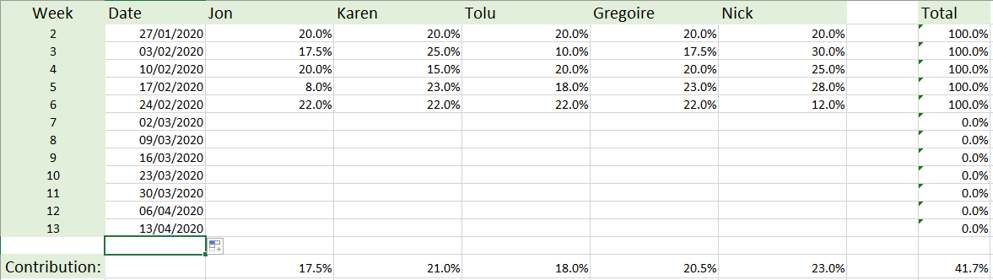

# Appendix